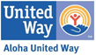
Public Media Advisory
FOR IMMEDIATE RELEASE
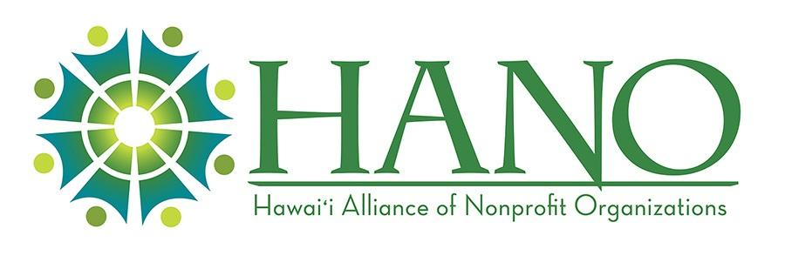
Jan. 30, 2025

Contacts:
Aloha United Way: Aga Westfal-Conboy, V.P. Marketing & Communications
Aloha United Way, Email: aga@auw.org / Phone: (808) 543-2201
Hawai‘i Alliance of Nonprofit Organizations (HANO): Melissa Miyashiro, President and CEO, Email: mmiyashiro@hano-hawaii.org / Phone: (808) 529-0454

Hawai‘i Nonprofits Rally Amid Federal Funding Uncertainty
Honolulu, HI — In response to ongoing uncertainty surrounding a recent federal directive to pause grants and loans, Aloha United Way (AUW), in collaboration with the Hawai‘i Alliance of Nonprofit Organizations (HANO), is working tirelessly to assess the potential impacts on critical services for Hawai‘i residents. This freeze threatens housing, food security, childcare, and disaster recovery programs that thousands rely on every day.
To better understand the scope of these disruptions, AUW and HANO have launched a survey for nonprofit partners and service providers. The data collected will help shape advocacy efforts and identify urgent needs across the state.
“Our nonprofit community is resilient, but these unprecedented actions introduce uncertainty that affects real lives,” said Michelle Bartell, CEO of Aloha United Way. “Each United Way in Hawai‘i administers federal funds that help local residents, including the Emergency Food and Shelter Program (EFSP). We stand with our nonprofit partners and will continue to advocate for the stability of these critical resources.”
Melissa Miyashiro, President and CEO of HANO, emphasized the broader implications: “While we are relieved that the memo directing a federal funding freeze was rescinded, the nonprofit sector remains vigilant. The impact from withholding federal grants and loans could jeopardize nonprofit programs that serve as lifelines for thousands. This could have rippling consequences for not only our communities, but our nonprofit workforce.”
Earlier this week, the White House sent a directive to federal agencies ordering them to pause most of their federal grants and loans — including billions of dollars to nonprofit organizations and service providers— beginning January 28th. A few hours before the freeze was to take effect, a federal judge ruled to temporarily block it. In response, the administration rescinded their funding freeze directive on the morning of January 29th. However, the Administration’s Executive Orders issued last week remain in effect, adding another layer of uncertainty as legal and policy battles unfold. Aloha United Way and HANO are monitoring developments closely, recognizing that many of these executive actions may be challenged in court, superseded by Congress, or further clarified in the coming weeks.

Possible Implications for Hawai‘i
- Housing Stability: Approximately 50,000 residents are currently receiving housing subsidies. Those people are now incredibly vulnerable: The freeze exacerbates the risk of homelessness across the state .
- Food Security: Interruptions to SNAP and food bank funding may leave families without access to essential nutrition.
- Childcare and Workforce: Programs like HeadStart face uncertainty, potentially leaving families without childcare and impacting workforce participation.
- Disaster Recovery: Funding delays for FEMA and DCMP could hinder ongoing and future disaster response efforts.
- Nonprofit Operations: Many local organizations rely heavily on federal grants to deliver essential services, making this freeze a significant threat to community stability.

Resources and Call to Action
- Take the Survey: Nonprofit and service providers are encouraged to share their anticipated impacts at this survey link.
- Contact 211: AUW’s 211 Helpline is available to connect individuals and nonprofits to resources and services. Call 211 or visit auw211.org
- Advocacy Efforts: HANO is mobilizing nonprofits to amplify their voices. Nonprofit and community members are encouraged to sign up for HANO email alerts.
For updates and more information, please contact AUW or HANO using the contact information above.

About Aloha United Way - Founded in 1919, Aloha United Way brings resources, organizations and businesses together to advance the health, education and financial stability of every person in our community. AUW has evolved over the years and adapted to meet our community’s greatest needs focusing on amplifying non-profit agencies and their work as well as the 211 statewide helpline, ALICE Initiative and Safety Net Fund. A member of United Way Worldwide, AUW supports nonprofits and communities on Oahu. For more information, visit AUW.org
About Hawai‘i Alliance of Nonprofit Organizations –
The Hawaiʻi Alliance of Nonprofit Organizations (HANO) works to strengthen and unite the nonprofit sector as a collective force to improve the quality of life in Hawai‘i. Since 2006, HANO has been a leading voice for the nonprofit sector, leveraging resources, educating and advocating for policies and practices that promote the professionalism, sustainability and effectiveness of nonprofits and the communities they serve.

###

